A.I

LAB TASK 10

Name: Syed Muzzamil Waseem

SID: 11067

CID: 110089

QUESTION

import numpy as npimport cv2

from google.colab.patches

import cv2_imshow

import matplotlib.pyplot as plt

%matplotlib inline image1=cv2.imread('/content/mountains.jpg') training_image = cv2.cvtColor(image1, cv2.COLOR_BGR2RGB)

training_gray = cv2.cvtColor(training_image, cv2.COLOR_RGB2GRAY) test_image = cv2.pyrDown(training_image)

test_image = cv2.pyrDown(test_image) num_rows, num_cols = test_image.shape[:2]

rotation_matrix = cv2.getRotationMatrix2D((num_cols/2, num_rows/2),90,1) test_image=cv2.warpAffine(test_image,rotation_matrix,(num_cols,num_rows))

test_gray = cv2.cvtColor(test_image, cv2.COLOR_RGB2GRAY) fx, plots = plt.subplots(1, 2, figsize=(20,10))

plots[0].set_title("Training Image") plots[0].imshow(training_image)

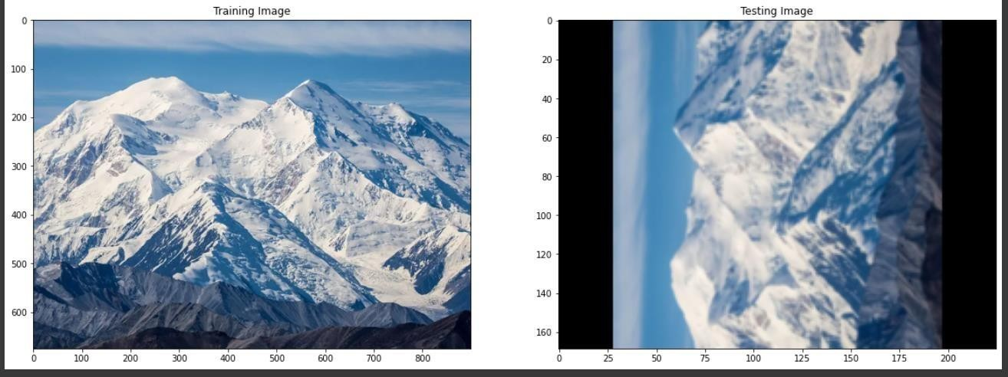

orb = cv2.ORB_create()

train_keypoints, train_descriptor = orb.detectAndCompute(training_gray, None)

test_keypoints, test_descriptor = orb.detectAndCompute(test_gray, None)

keypoints_without_size = np.copy(training_image)

keypoints_with_size = np.copy(training_image)

cv2.drawKeypoints(training_image, train_keypoints, keypoints_without_size,color = (0, 255, 0))

cv2.drawKeypoints(training_image, train_keypoints, keypoints_with_size, flags = cv2.DRAW_MATCHES_FLAGS_DRAW_RICH_KEYPOINTS)

sizefx, plots = plt.subplots(1, 2, figsize=(20,10))

plots[0].set_title("Train keypoints With Size") plots[0].imshow(keypoints_with_size, cmap='gray')

plots[1].set_title("Train keypoints Without Size") plots[1].imshow(keypoints_without_size, cmap='gray')

print("Number of Keypoints Detected In The Training Image: ", len(train_ke ypoints))

print("Number of Keypoints Detected In The Query Image: ", len(test_keypoints))

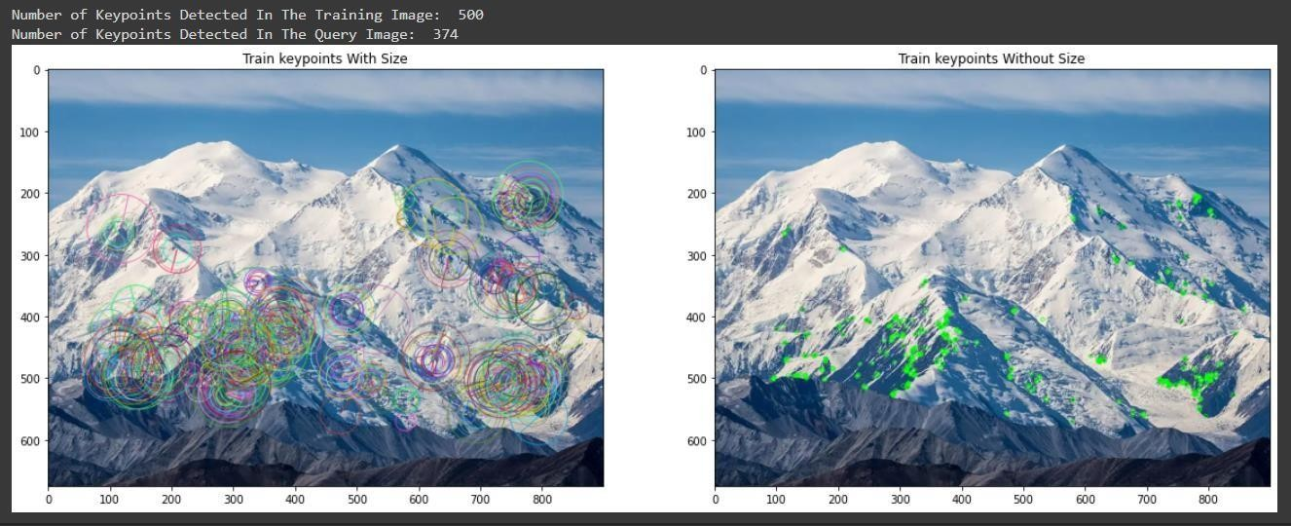

bf = cv2.BFMatcher(cv2.NORM_HAMMING, crossCheck = True) matches = bf.match(train_descriptor, test_descriptor)= sorted (matches, key = lambda x : x.distance)

result = cv2.drawMatches(training_image, train_keypoints, test_gray, test_ keypoints, matches, test_gray, flags = 2)

plt.rcParams['figure.figsize'] = [14.0, 7.0] plt.title('Best Matching Points') plt.imshow(result)

plt.show()

print("\nNumber of Matching Keypoints Between The Training and Query Image s: ", len(matches)

